**MICROSOFT**

**AZURE**

S.R.TAANUSRI

29.12.2023

1. Create data bricks resource from the microsoft resource available in the search box

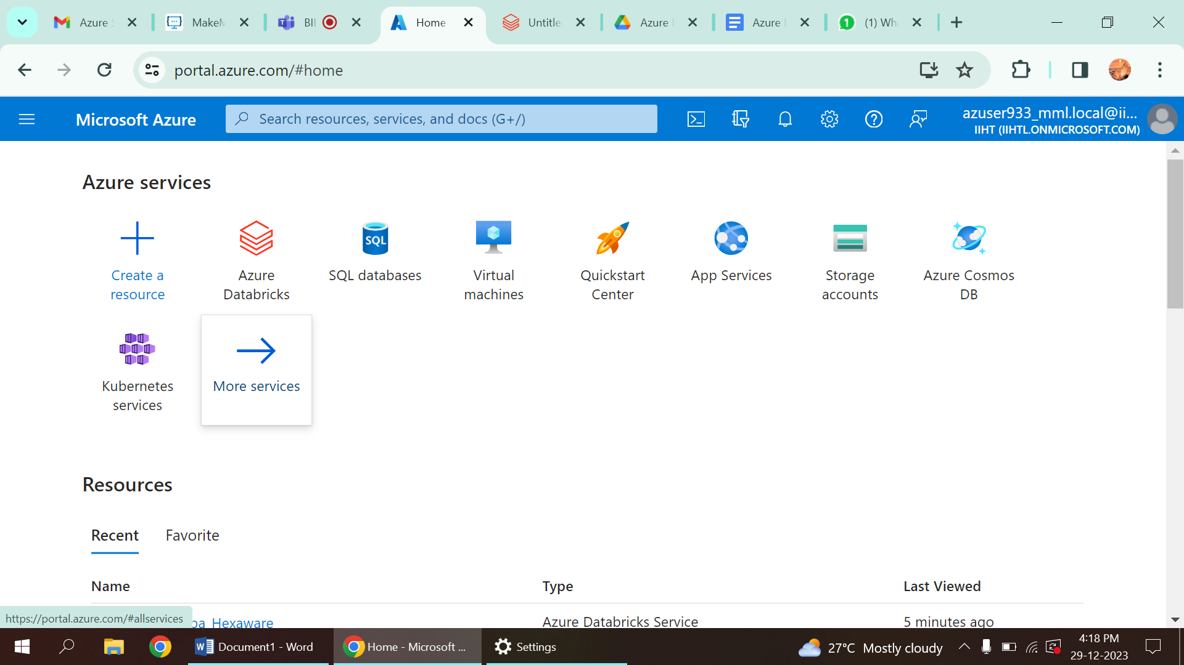

2.From the exisisting assure resource type create a new cluster

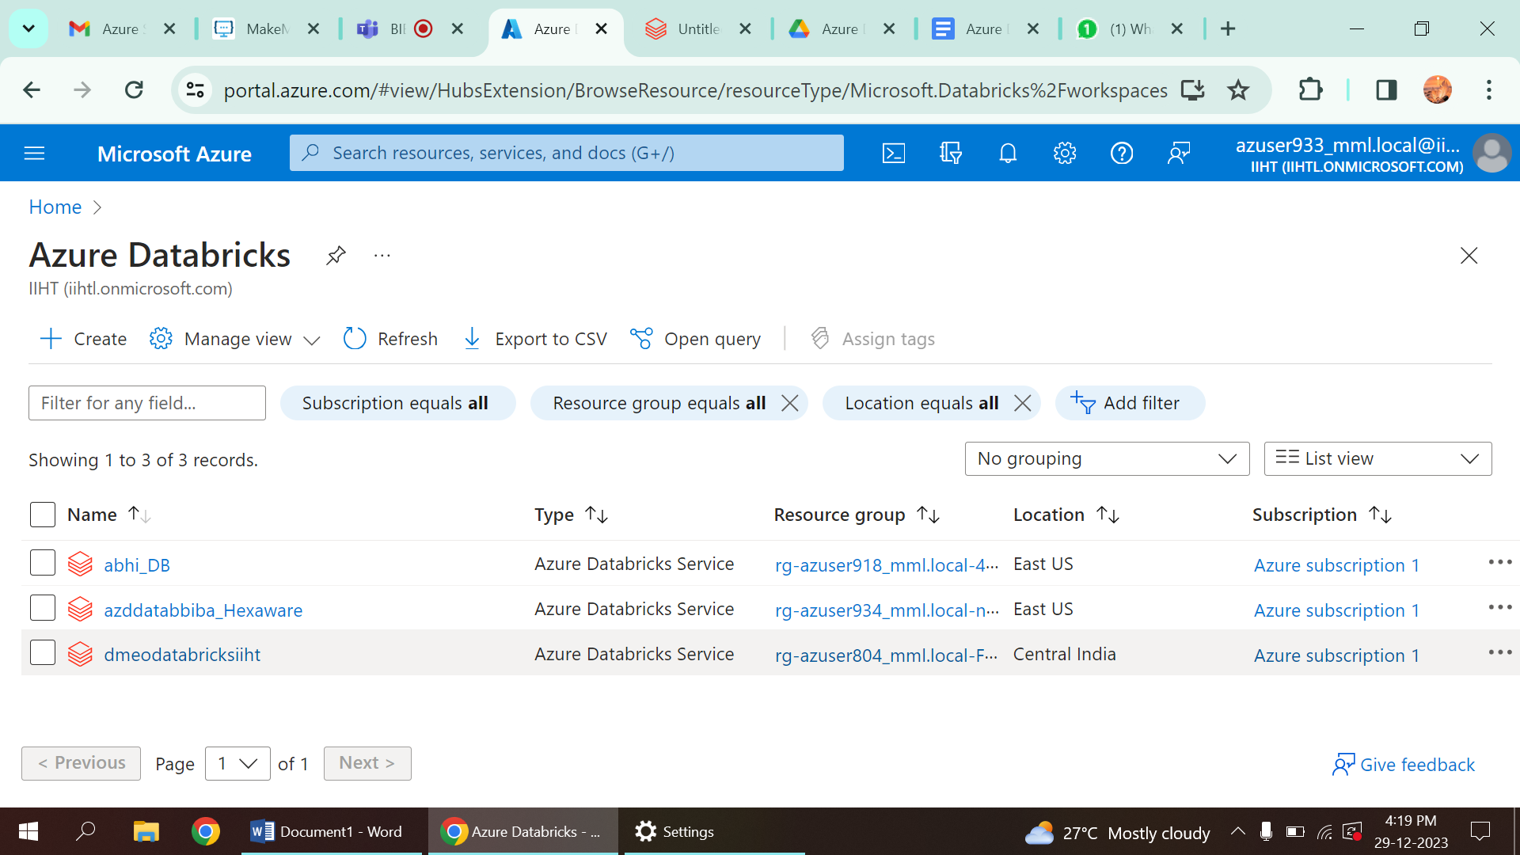

3.After opening the resource click on workspace

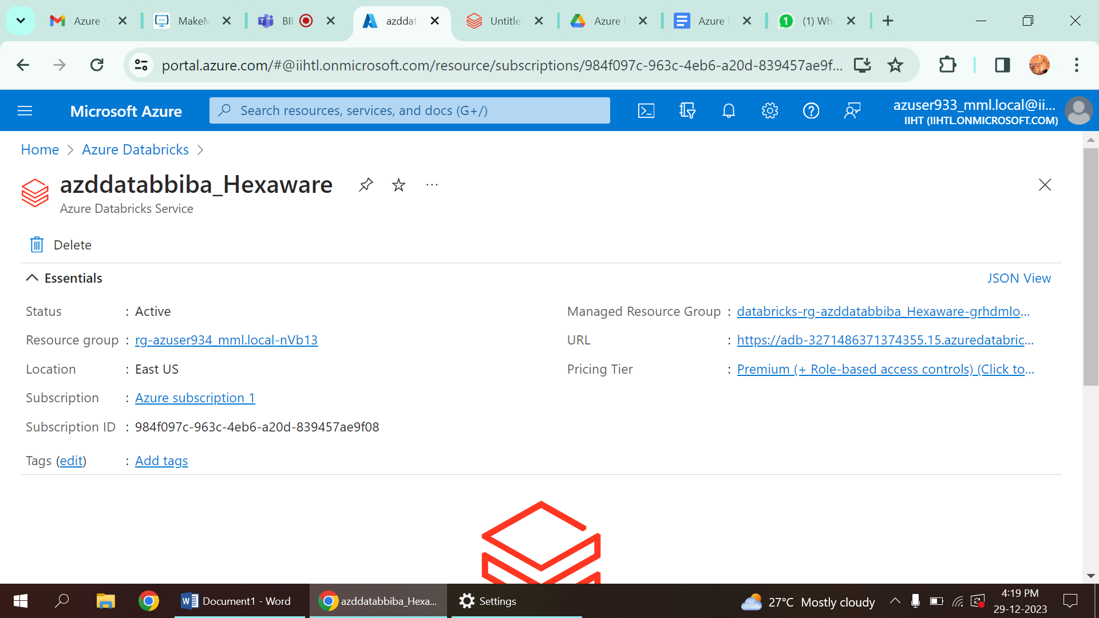

4.Then the azure will get directly signed with the microsoft acount associated with databrics,we can see a new workspace created.

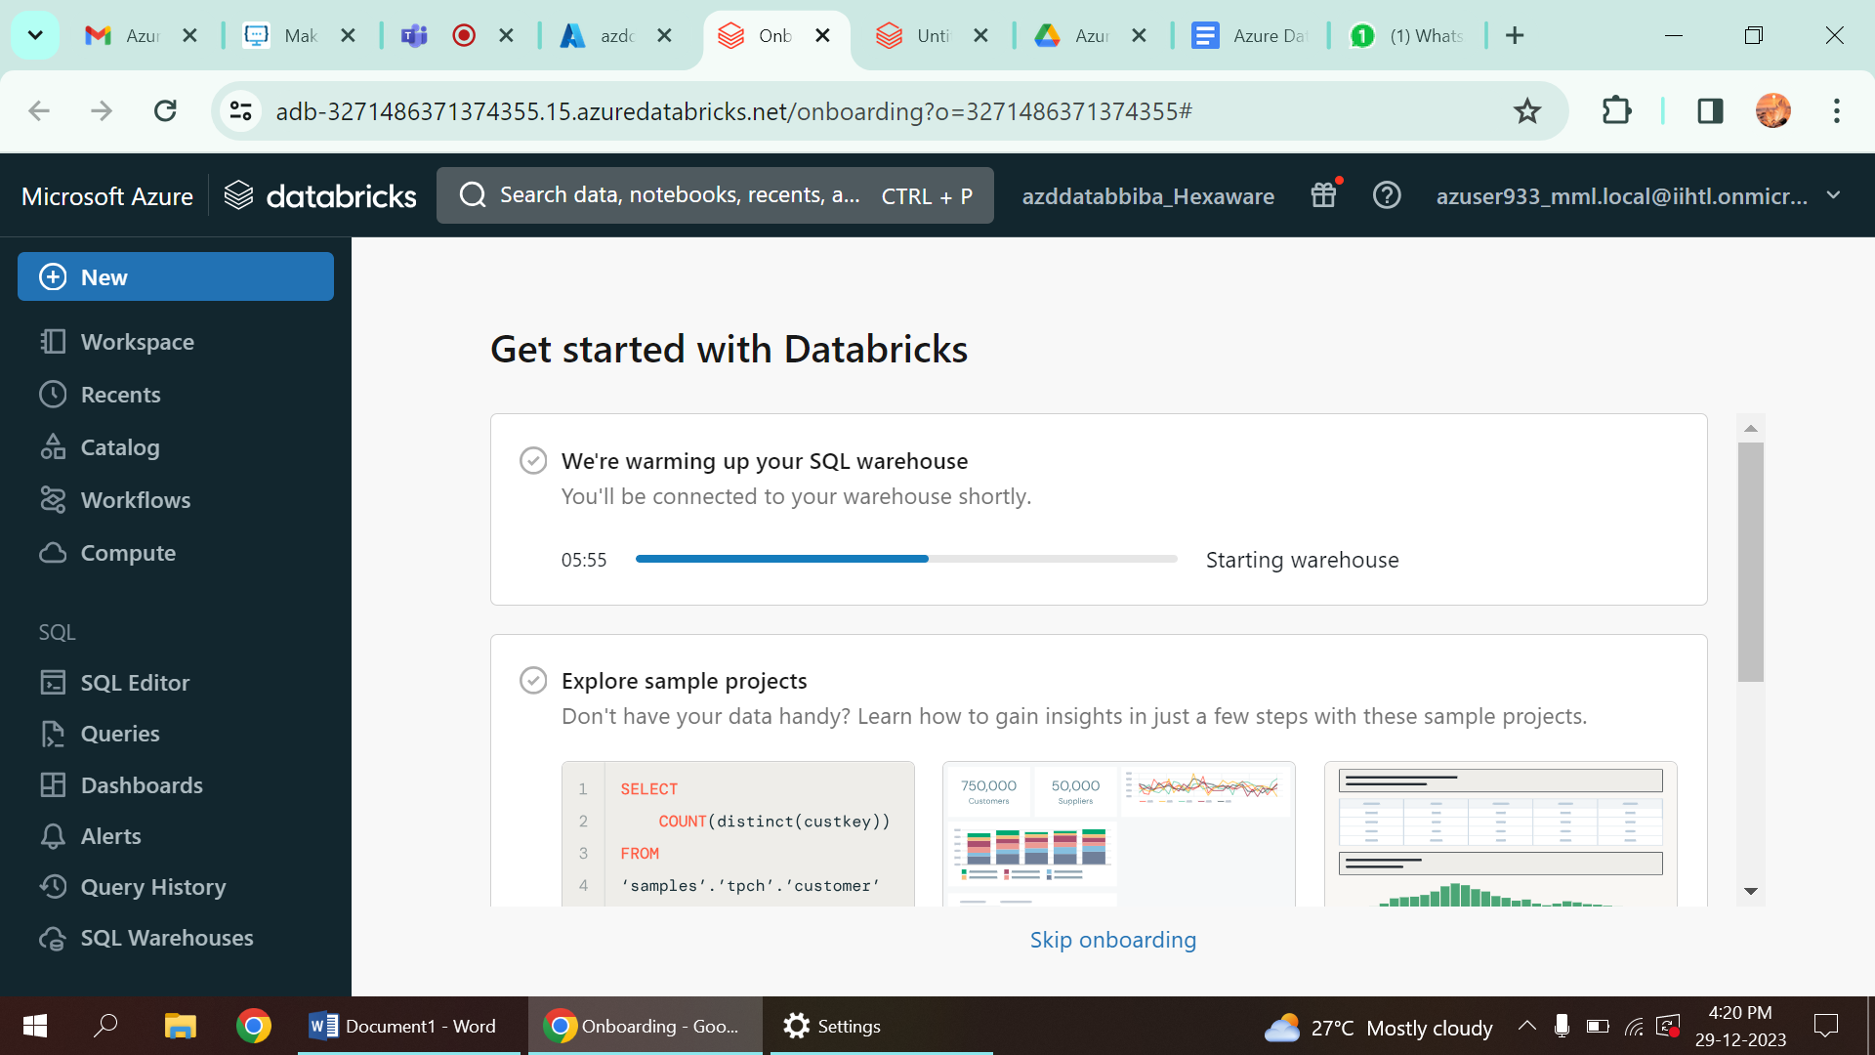

5.Creating a cluster by clicking new from workspace and then create a cluster

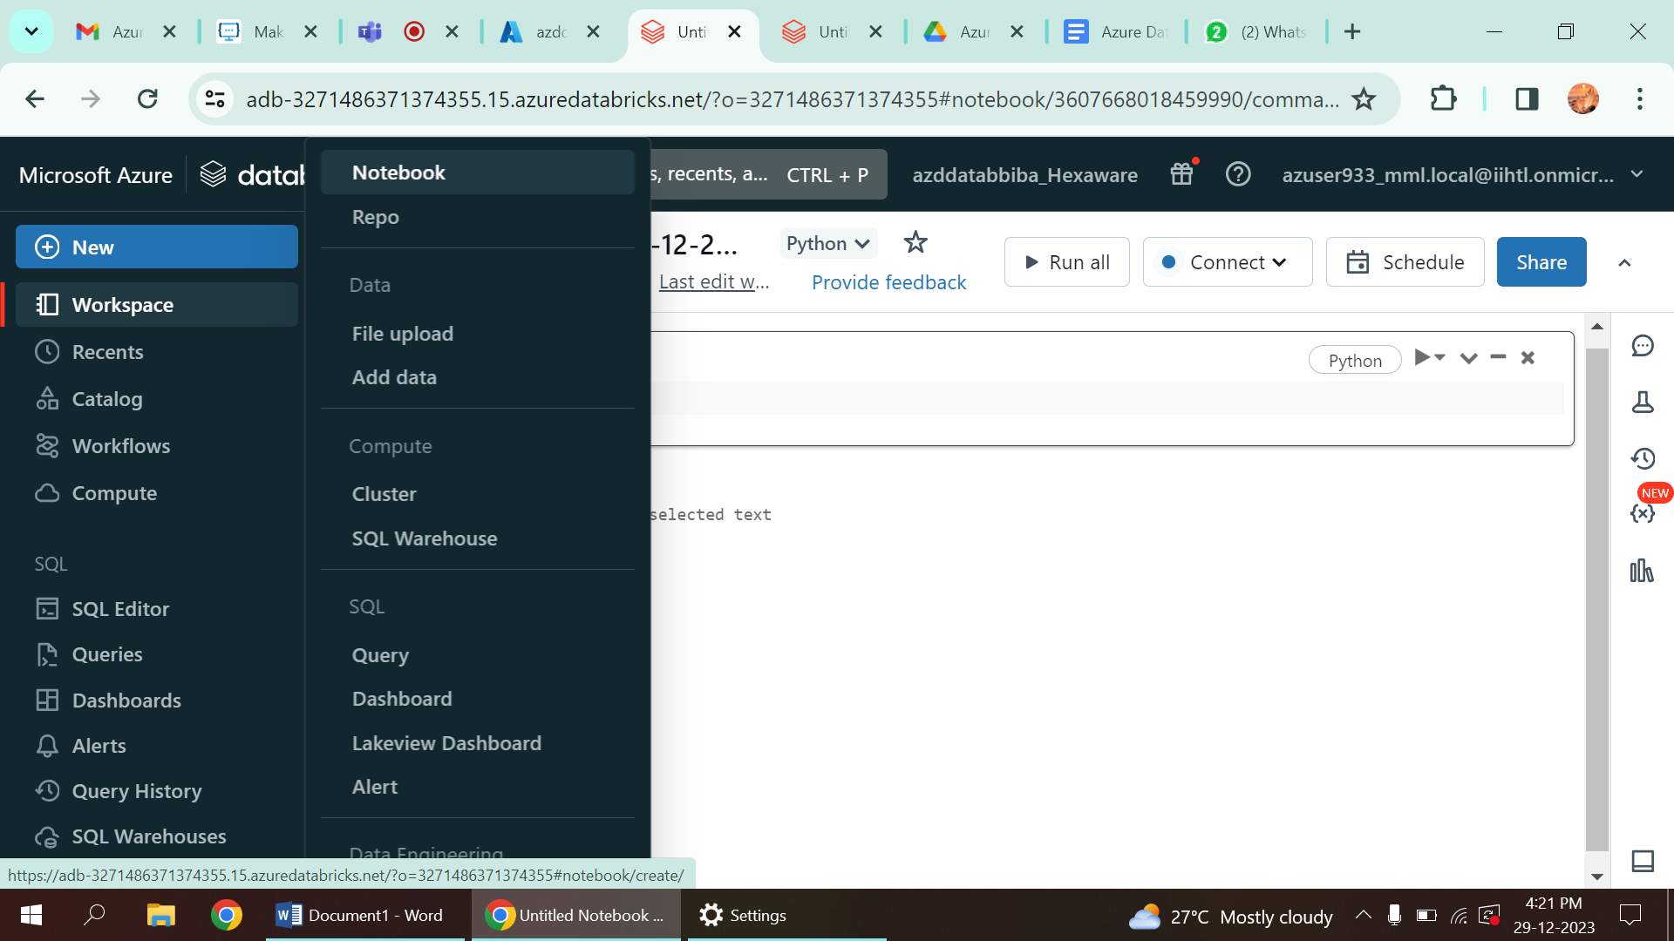

6.Creating a personal compute single operator cluster with 14.2 ml runtime

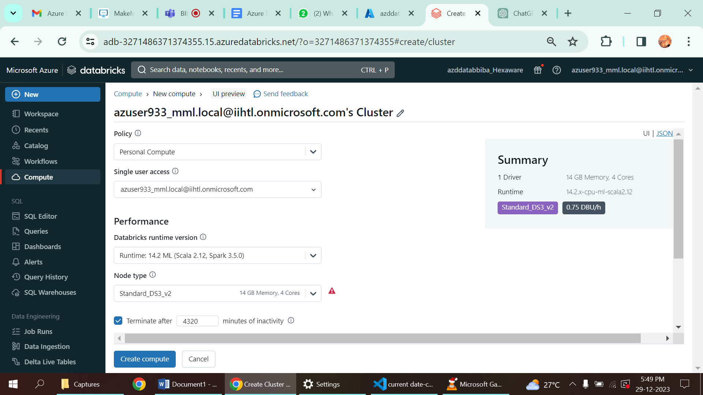

7.Click on new again and click note book. after that a new note book Is created and after importing the necessary package we can run the necessary programs. Also need to select the programming language. After running the cluster terminate the cluster and delete it.

A program is create for printing current date using pyspark.

